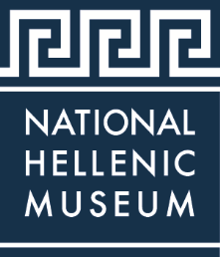

Media Contact:
Helene Genetos
National Hellenic Museum
333 South Halsted Street
Chicago, IL 60661
Office: 312.655.1234 ext. 28
Email: hgenetos@hellenicmuseum.org
Website: www.nationalhellenicmuseum.org

FOR IMMEDIATE RELEASE

The National Hellenic Museum to hold Annual Gala – “Connecting Generations”
Tickets and sponsorships now are available
CHICAGO (March 30, 2018) – The National Hellenic Museum (NHM) will hold its Annual Gala “Connecting Generations” Saturday, May 12, at the Chicago Marriott Downtown Magnificent Mile. The NHM Gala has always been a great opportunity for hundreds of Greek Americans and friends from across the country to gather together for a night of festivities and philanthropy. The evening features spectacular auctions, live music, and dancing while celebrating and supporting the legacy of Hellenism.
Philanthropic support from NHM Gala 2018 will benefit the tens of thousands of people - children and adults - who visit the National Hellenic Museum every year through field trips, tours and dynamic cultural and historical programs. Last year, the NHM achieved a 29 percent year-over-year increase in people served. Operationally, the NHM has been highly efficient with 81 cents of every dollar spent on programming, an excellent ratio among non-profit museums.
The Museum preserves the largest collection of artifacts and oral histories dedicated to the Greek American story anywhere in the world. Special events help to fund classes, field trips, tours, programs, and, as highlighted in this year’s theme, the protection of the museum archives and the important memories preserved for all. The artifacts in the NHM Collections serve as a crucial component of NHM’s educational outreach.
Individual NHM Gala tickets are $350 and tables of 10 are $3,200. To purchase tickets or inquire about sponsorship opportunities, visit www.nationalhellenicmuseum.org/gala or call 312-655-1234 x28. Hotel reservations also can be made online, with a group rate available for reservations made by April 20.

###

About the NHM Gala 2018 Design

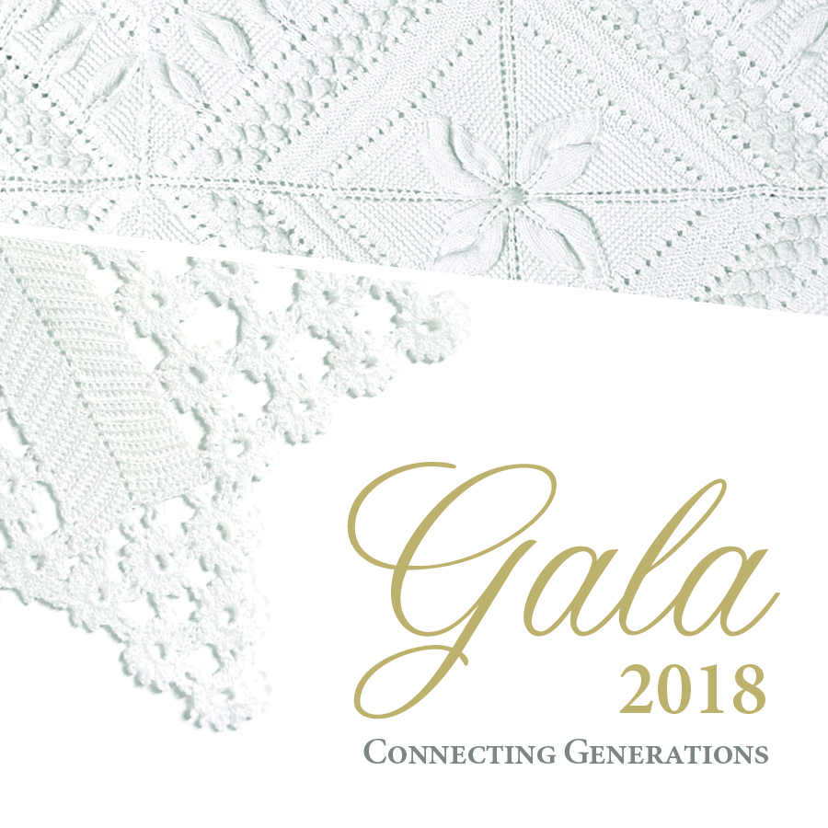

The textiles featured on the Gala design are preserved in the NHM Collections and Archives.
The embroidered pillows and crocheted doilies that decorated Greek living rooms are as beautiful as any painting. The quilts and garments that guarded us against the cold are functional and they are also art. Moreover, these pieces are important heirlooms that carry with them the memories and love of the women who made them. These are the threads that bind cloth – and also connect families and generations across oceans and continents.
At the National Hellenic Museum, we protect, preserve, and celebrate the many diverse threads of the Hellenic experience – and we use our collections in teaching about the fullness of Greek history.

Hotel Info

Location: Chicago Marriott Downtown Magnificent Mile
540 North Michigan Avenue
Chicago, IL 60611

Reservations: https://book.passkey.com/event/49213515/owner/1361/home

Press Passes
Working press wishing to attend the event must contact Helene Genetos to reserve their press pass at hgenetos@hellenicmuseum.org.
Images
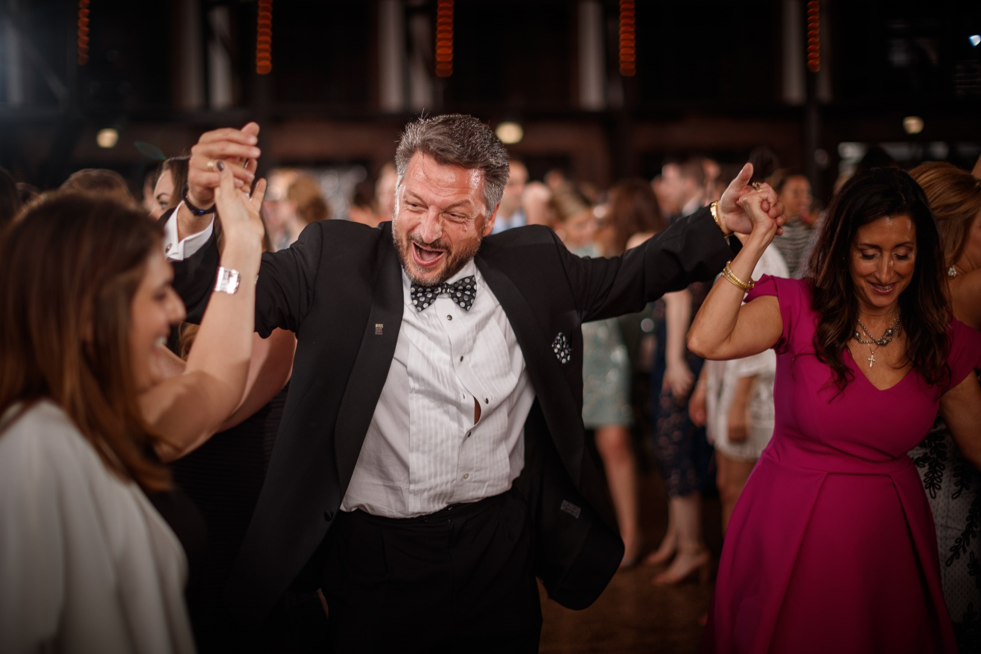
National Hellenic Museum Trustee Aristotle P. Halikias enjoys dancing with family and friends at NHM Gala 2017
Photo Credit: John Gress 2017

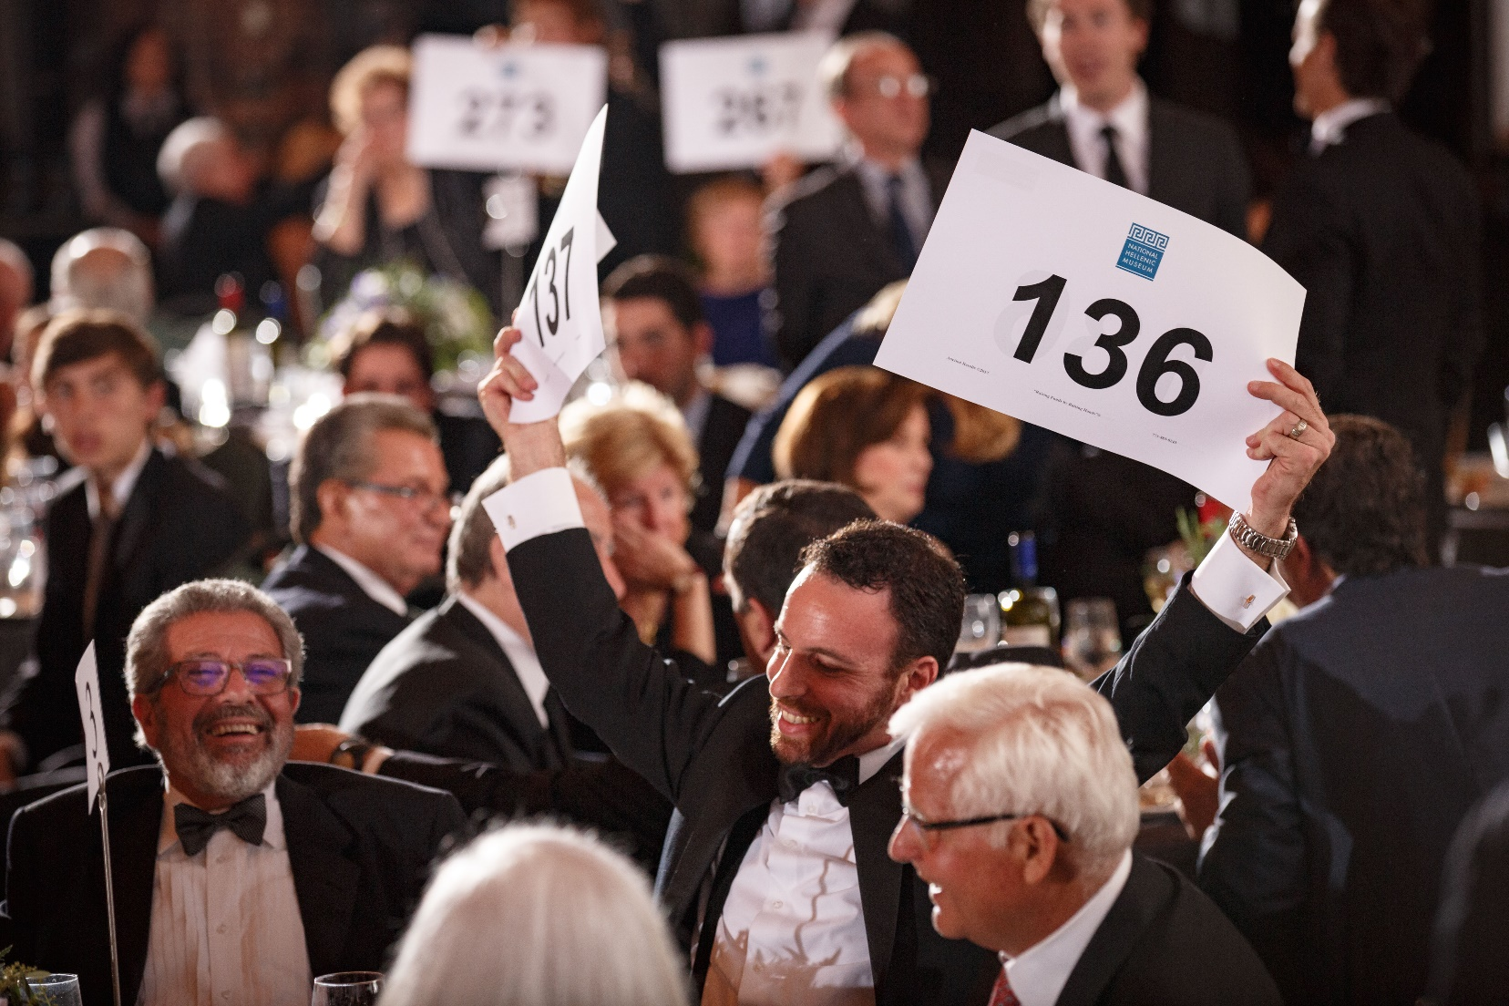
Support for the NHM at Gala 2017 was so strong bidders needed two paddles
Photo Credit: John Gress 2017

About the National Hellenic Museum
The National Hellenic Museum (NHM) portrays and celebrates Greek heritage and the Hellenic legacy through educational classes, exhibits and programs. With a growing repository of over 20,000 artifacts, the Museum catalogs and highlights the contributions of Greeks and Greek Americans to the American mosaic and inspires curiosity about visitors’ own family journeys through cultural expression, oral history and experiential education. Located in Chicago’s Greektown, the NHM provides lifelong learning for the whole community using artifacts and stories to spark inquiry and discussion about the broader issues in our lives.
For more information, visit http://www.nationalhellenicmuseum.org or call 312-655-1234.
Follow NHM on Facebook, Instagram, and Twitter

