Media Contact: FOR IMMEDIATE RELEASE
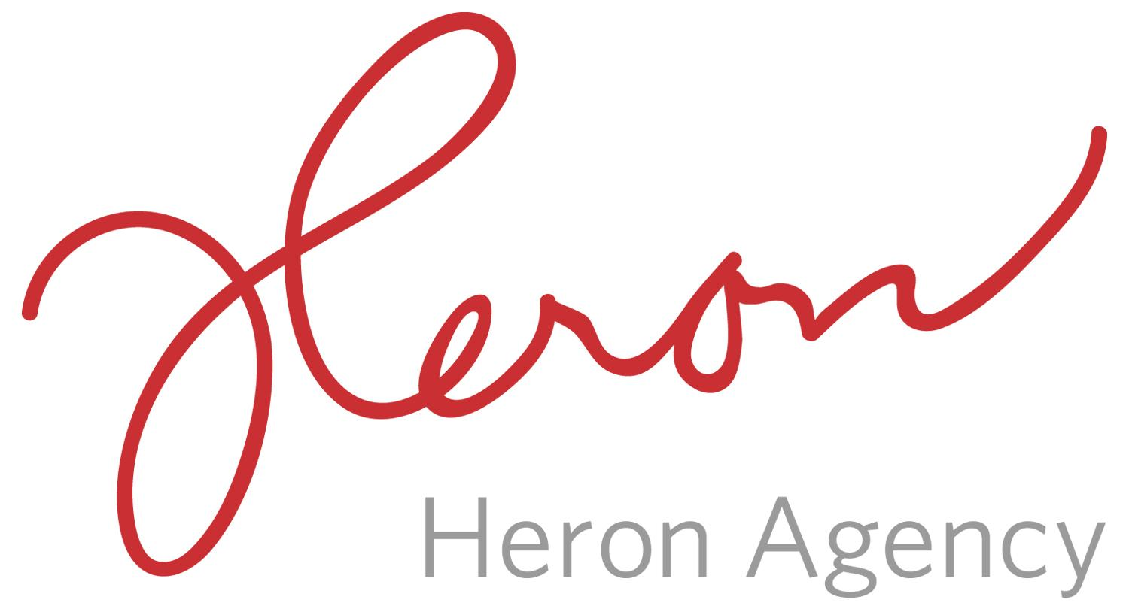
Sarah Ficek/Megan Gasper
sarah@heronagency.com
megan@heronagency.com
www.heronagency.com
773.969.5200

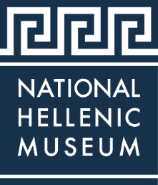

THE NATIONAL HELLENIC MUSEUM ANNOUNCES NEWEST EXHIBIT – GEORGE KOKINES: LAYERS REVEALED – OPENING SEPTEMBER 20, 2018

CHICAGO (August 2018) – Dedicated to collecting, preserving and portraying the legacy of Greek history and culture in America, the National Hellenic Museum has the largest collection of Greek American artifacts and recorded oral histories anywhere. The National Hellenic Museum (NHM), 333 S. Halsted St., introduces its newest exhibition — George Kokines: Layers Revealed. On September 20, 2018, the National Hellenic Museum will open the first ever retrospective of the artist George Kokines. Using loaned objects and those from the NHM Collections, this exhibition traces Kokines’ artistic development and accomplishments in Abstract Expressionism as well as his journey to embrace his Greek American identity.

Kokines’ art employed free-form organic and geometrical forms, abstract figures and intense spaces of color. He inserted humor, references to Greek mythology and his life experiences into his work. When working with nontraditional materials like wax, plaster and concrete, Kokines often carved through the layers he had built up on the surface. He was known to rework older pieces many times over. Palimpsest — something altered that bears visible traces of its previous form — was a concept that is apparent in much of Kokines’ work.

In 1993, Kokines traveled through Greece, making stops at his parents’ hometowns on a trip that allowed him to connect his history and artwork to ancient Greece. Later in his life, Kokines was deeply impacted when he witnessed the events of September 11, 2001 first hand, watching as the World Trade Center fell. The largest installation of his career, September 11, was created in remembrance of the day and will be exhibited. The installation includes the painting Agios Nikolaos, representing the small Greek Orthodox church that also stood at Ground Zero.

Kokines was born in 1930 in Chicago to Greek immigrant parents. He studied at the School of the Art Institute of Chicago, earning a BFA in 1960. Early in his career he received critical acclaim and was a prominent figure in the Chicago art community. Once the subject of controversy, he said, “All contemporary painting should defy description.” In 1966, he moved to New York where he lived and worked for nearly 40 years. In 2005, he returned to Chicago and continued to paint until he passed away in 2012. Kokines’ work was exhibited in galleries and museums nationally and internationally, including the Art Institute of Chicago, the Whitney Museum, the Richard Gray Gallery, the Centro Cultural in Buenos Aires, Argentina and the Palazzo Massari in Ferrara, Italy.

The works in this exhibition exemplify Kokines’ improvisation and the textural and large-scale style of his work. Demonstrating his mastery of abstraction, this exhibition reveals the brilliance and skill of George Kokines. Related educational programming, docent-led tours and field trips for school children will be offered throughout the year.

Founded in Chicago as the Hellenic Museum and Cultural Center (HMCC) in 1983, the HMCC moved to the city’s Greektown neighborhood in 2004 and opened its current location on Halsted Street as the National Hellenic Museum in 2011. The contemporary four-story building is home to extensive collections, rotating exhibitions, classrooms, and a stunning rooftop view of Chicago. Three floors of galleries explore ancient and modern themes and provide multi-use spaces to host tours, public programs, and private events. The NHM boasts a rich repository of 20,000+ artifacts, photos, historic newspapers, books and an archive of 450+ recorded histories. The NHM Collections & Archives serve as a central repository of Greek American history, now many generations strong. The Museum celebrates the mosaic of the Greek diaspora, immigrant journeys, and the breadth of the American experience.
The National Hellenic Museum is open to all ages with admission as follows: adults $10, seniors $8, students $8, and children 3 to 12 years are $7. Children under 3 years of age and members receive free admission. NHM is open Tuesdays, Wednesdays and Fridays from 11 a.m. to 5 p.m., Thursdays from 11 a.m. to 8 p.m., Saturdays and Sundays from 11 a.m. to 5 p.m. and is closed on Mondays. Members enjoy many additional outstanding benefits throughout the year.
NHM counts on member support to help preserve and share Greek history and culture through programs, events, and exhibitions. To become a member of the NHM, please visit the Museum’s membership page. For more information about George Kokines: Layers Revealed and other programs, membership, special events, facility rentals, or giving, please visit www.nationalhellenicmuseum.org.
###

Images
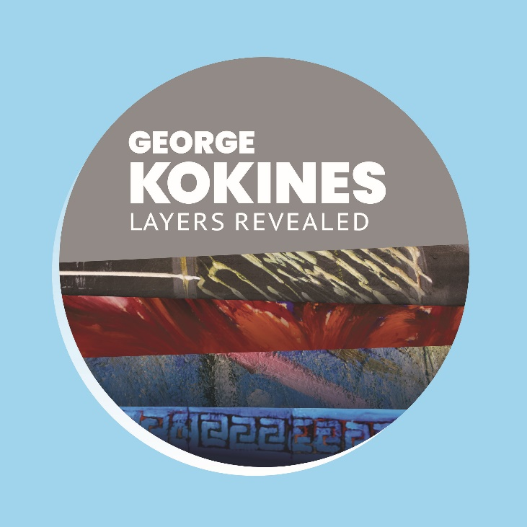
George Kokines: Layers Revealed opens on September 20th at the National Hellenic Museum.

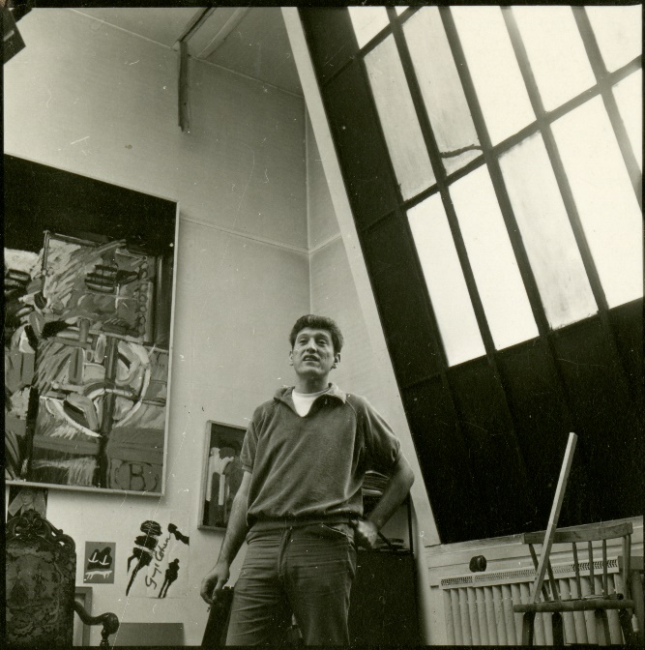
Photograph of George Kokines in his Ravenswood neighborhood studio, early 1960s. NHM Collections.

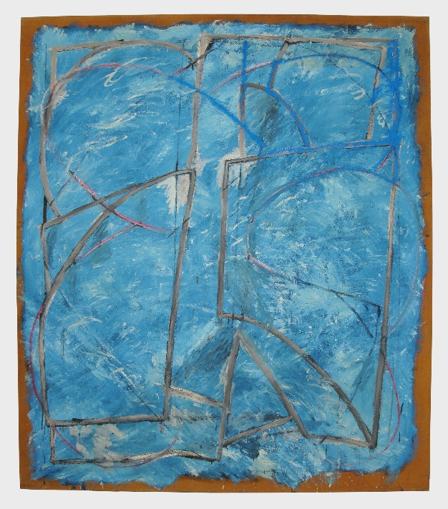
Aeriobatis, 1990, will be shown in NHM’s newest exhibition “George Kokines: Layers Revealed” opening Sept. 20th.

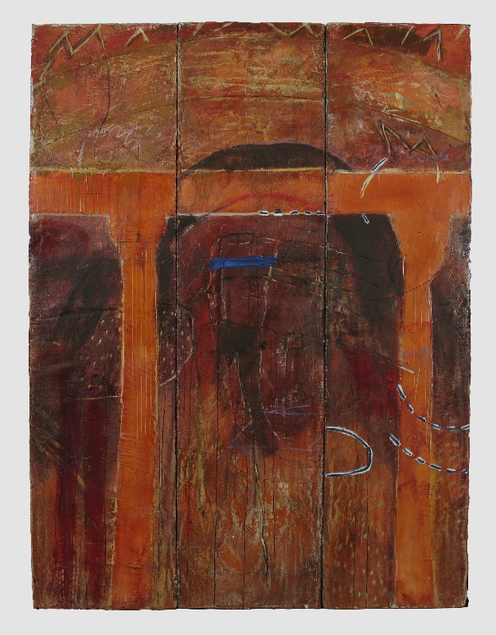
Labyrinth Wall, c. 1993, will be shown in NHM’s newest exhibition “George Kokines: Layers Revealed” opening Sept. 20th.

About the National Hellenic Museum
The National Hellenic Museum (NHM) portrays and celebrates Greek history and the Hellenic legacy through educational classes, exhibits and programs. With a growing repository of over 20,000 artifacts, the Museum catalogs and highlights the contributions of Greeks and Greek Americans to the American mosaic and inspires curiosity about visitors’ own family journeys through cultural expression, oral history and experiential education. Located in Chicago’s Greektown, the NHM provides lifelong learning for the whole community using artifacts and stories to spark inquiry and discussion about the broader issues in our lives.
For more information, visit http://www.nationalhellenicmuseum.org or call 312-655-1234.Follow NHM on Facebook, Instagram, and Twitter.

