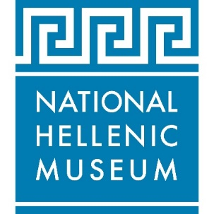
FOR IMMEDIATE RELEASE Press contact: PR Consultant Elizabeth Neukirch
Press images available HERE >> elizabethneukirchpr@gmail.com / 815.751.5844

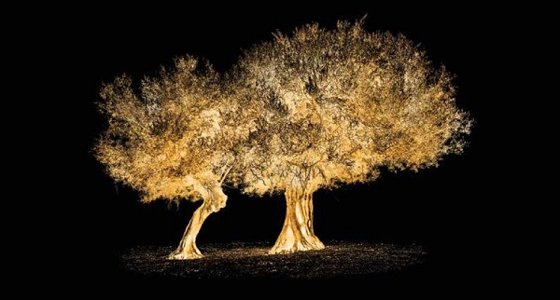
Together, photo by HRH Prince Nikolaos

Chicago’s National Hellenic Museum reopens with world premiere of
major photography exhibition

Resilience
By HRH Prince Nikolaos

September 16 – December 30, 2022

Prince Nikolaos’ first North American exhibition features new works
exploring Greece’s strong relationship with nature and environmental preservation

CHICAGO (July 21, 2022)—The National Hellenic Museum (NHM) in Chicago’s Greektown neighborhood celebrates its grand public reopening in September with the world premiere of a major photography exhibition, Resilience by HRH Prince Nikolaos, September 16 through December 30, 2022.

An accomplished photographer who has exhibited his work internationally since 2015, Prince Nikolaos will present 19 new works as part of the NHM exhibition, exploring Greece’s strong relationship with nature including the olive tree, grapevines and the sea. The exhibition will also feature the North American premiere of Together, an immersive scene of life-size illuminated, embracing olive trees accompanied by sounds of Greek nature, which first premiered at the London Design Biennale in 2021.

“Greece’s past, present and future is intertwined and inextricably linked with nature. The recent pandemic has changed how we view the physical world and our space within it and has forced us to go back to our origins to find inspiration,” says Marilena Koutsoukou, curator of Resilience. “As an artist, Prince Nikolaos is always drawn to open spaces, and nature has been an integral theme and presence in his work. With this exhibition, he turns his lens to the Greek earth. Like an archaeologist meticulously excavating, recording, and drawing conclusions, he attempts to deconstruct and explore our collective experience with a new normal, a shared belief that we must let go of our past ways and find ways to celebrate and protect nature, and eventually, ourselves.”

A central piece of the Resilience exhibition is a photographic mosaic titled Sea Cred, created by Prince Nikolaos in collaboration with nonprofit environmental organization Parley for the Oceans, to raise awareness of the plastic pollution of our oceans and bodies. The artwork is divided and printed onto 272 credit cards made of Parley Ocean Plastic®, upcycled ocean plastic debris from remote beaches, mangroves and coastal communities. Sea Cred is inspired by the fact that humans could be consuming an average of 5 grams of plastic every week, the equivalent weight of a credit card, according to a 2019 University of Newcastle study commissioned by the World Wildlife Fund.

The Resilience exhibition is sponsored by NHM Trustee John S. Koudounis.

“We are thrilled and honored that HRH Prince Nikolaos has chosen the National Hellenic Museum for his North American debut. He is a renowned artist whose work has been exhibited in major global cities including Athens, London, Copenhagen, Doha and Melbourne—and now Chicago audiences and visitors from across the country will have the opportunity to experience his striking and impactful images,” says Koudounis.

“We are delighted to welcome the public back to the museum to experience these exquisite images as seen through the lens of an artist who captures the magnificent and timeless beauty of nature,” adds NHM Executive Director Marianne Kountoures. “Prince Nikolaos’ work encourages us to consider how the natural world impacts us and how we can preserve it for generations to come."

Resilience by HRH Prince Nikolaos will be exhibited at the National Hellenic Museum (333 S. Halsted Street, Chicago) from September 16 through December 30, 2022. Museum hours are Friday-Sunday from 10 a.m.-5 p.m. Tickets to the museum are $10 and include admission to all exhibits. Discounts are available for seniors, students and children. For more information, visit nationalhellenicmuseum.org or call 312-655-1234.

Artist bio

HRH Prince Nikolaos was born in October 1969, in Rome, Italy, to parents TM King Constantine and Queen Anne-Marie. In 1975, the family settled in London, where Prince Nikolaos was home educated for six years. He then attended the Hellenic College of London. In 1988, he began his studies in international relations at Brown University in Providence, Rhode Island, focusing on Diplomacy and National Security. During his sophomore year, he took a sabbatical to join the British Army on a Short Service Limited Commission, serving as 2nd Lieutenant with the Royal Scots Dragoon Guards. Upon his college graduation, Prince Nikolaos moved into TV production for Fox News in New York. He returned to London in 1995 to work in the foreign exchange options department of NatWest Markets. From 1997 to 2003 he worked in King Constantine’s Family Office. Since then, he has been active in business consulting.

An avid photographer for all his life, Prince Nikolaos has passionately dedicated himself to photography since 2013. In November 2015, he exhibited his work for the first time at Christie’s in London. In March 2016, his photography was featured at The New York Times’ Art for Tomorrow conference in Doha, Qatar. A selection of his photographs were also published in the book A Taste
of Greece, published by teNeues. In June 2018, Prince Nikolaos had his first solo museum exhibition, titled “Phos: A Journey of Light,” at the Hellenic Museum in Melbourne, Australia. The artist was then commissioned by LA Organic to produce a work, after the recommendation of Philippe Starck studio, which is currently exhibited at La Almazara, Spain. In November 2018, the artist was invited by Sotheby’s Jewelry to show 10 photographs from his series “Phos” to a select audience. Sotheby’s experts have dubbed prince Nikolaos’ photographs “Jewels from Greece.” In March of 2019, his collection titled “Celestial Choreography” was exhibited in Rundetaarn, one of the most iconic buildings of Copenhagen, to great critical acclaim. In October and November of the same year, his dual exhibition “Aegean Desert” opened up in Athens, Greece and Doha, Qatar, respectively. The exhibition, pairing images from the sea with images of the desert presented within site-specific art installations, was the first institutional collaboration between Benaki Museum of Islamic Art in Athens and Katara - Cultural Village Foundation in Doha. In June 2021, Prince Nikolaos exhibited his work “Together” at the London Design Biennale. There, he presented an enchanted, immersive scene of illuminated, life-sized olive trees reflected in mirrors and surrounded by sounds of Greek nature.

HRH Prince Nikolaos sits on the Board of Knightsbridge Schools International, established in 2008 to develop and operate a network of international schools around the world. He is an active member and Advisor to the Board of Axion Hellas, a Greek nonprofit volunteer organization supporting local communities in remote parts of the country. Prince Nikolaos and his wife Princess Tatiana (née Tatiana Blatnik) married in 2010. Three years later, they moved to Athens, Greece, where they currently reside.

About the National Hellenic Museum

The National Hellenic Museum (NHM) is a premier museum dedicated to sharing Greek history, art and culture, from ancient times to the present day, including the modern Greek American experience. NHM preserves the Hellenic legacy and makes this rich heritage relevant today through its collection of thousands of physical artifacts, oral histories, exhibits, educational programs and special events. Originally founded in 1983 and located in Chicago’s historic Greektown neighborhood since 2011, the NHM provides lifelong learning for the community and sparks inquiry and discussion about the broader issues in our lives and society. For more information, visit nationalhellenicmuseum.org or call 312-655-1234.

# # #

